RETAIL INVENTORY OPTIMIZATION
(Optimizing stock levels to identify fast and slow-moving items for predictive inventory management)

MAINAVATHY.E

Master Program in Data Analytics

November 2025

1. PROJECT OVERVIEW:
This project analyzes retail inventory data with over 5,000 records across various product categories and warehouses. The goal is to optimize stock levels by identifying fast- and slow-moving items, monitoring warehouse efficiency, and providing predictive insights to minimize overstocking and shortages. The outcomes aim to guide inventory management and supply chain decisions.

2. DATASET SUMMARY:
Rows | Columns | Null values
5,000 | 20 | 21

KEY FEATURES:
- SKU details: sku_id, item_name, category
- Stock info: opening_stock, stock_in, stock_out, closing_stock, reorder_level
- Price & discount: unit_price, discount_applied, sales_value
- Warehouse info: warehouse
- Performance metrics: stock_turnover
- Supplier info: supplier, lead_time_days
- Date of transaction: date
- Customer info: is_subscriber
- Missing Data: 21 null values across several columns:
Sku_id -1, Item_name-3, Category-3, Warehouse-1, Opening_stock-1, Stock_out-1, Unit_price-2, Sales_valu-1, Reorder_level-2, Supplier-1, Discount_applied -1, Review_rating 2, Stock_turnover -2.
Handling: Null values were replaced with 0 (for numeric columns) or left as is for categorical columns if needed.
3. EXPLORATORY DATA ANALYSIS USING PYTHON:
We performed data preparation and cleaning in Python:
- Data Loading: Imported the dataset using pandas.
- Initial Exploration: Used df.info() and df.describe() to check structure and summary statistics.
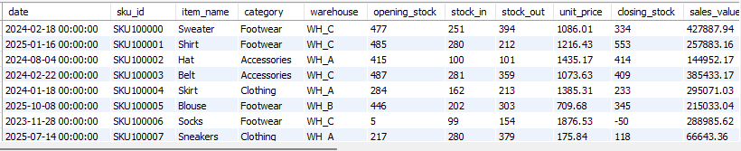

- Missing Data Handling: Identified 21 null values and replaced missing numeric values with 0.
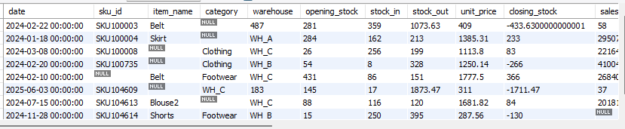
- Column Standardization: Converted column names to lowercase snake_case.
- Duplicates Removal: Dropped duplicate rows.
- Feature Engineering:
Closing_stock = opening_stock + stock_in - stock_out
Average_stock = (opening_stock + closing_stock)/2
Stock_turnover = stock_out / average_stock (avoiding division by zero)
- Date Conversion: Converted date column to datetime.
- Fast vs Slow-Moving Items: Classified items based on whether stock_turnover is above or below the mean.
- Monthly Sales Trends: Monthly stock-outs per SKU were analyzed to identify top-selling itwms and peak demand periods, helping to optimize inventory levels.
- Database Integration: Connected Python script to MySQL (retailproject) and successfully saved the cleaned data to the inventory table.
4. DATA ANALYSIS USING SQL (INVENTORY MANAGEMENT):
We performed structured analysis in MySQL to answer key inventory questions. The following tables were created:
Table Purpose:
1.Top_sku – Identified the top 10 SKUs by total stock-out.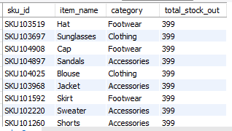

2. Slow_skus – Listed SKUs with below-average stock turnover.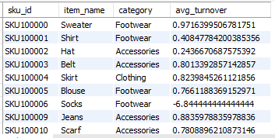

3. Warehouse_performance – Calculated total stock-in/out and average turnover per warehouse.
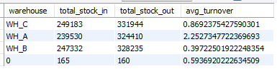

4. Category_summary – Summarized stock-in/out and average turnover per category.
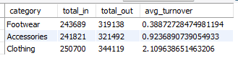

5. Monthly_sales – Aggregated monthly stock-out per SKU to track trends.
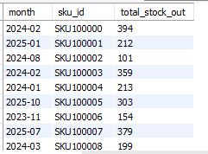

6. Reorder_analysis – Highlighted SKUs needing reorder (closing_stock < reorder_level).
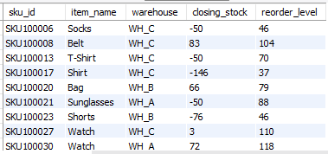
7. Supplier_performance – Analyzed supplier lead time and average stock turnover.
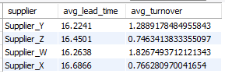

8. Price_performance – Compared sales per SKU versus unit price.
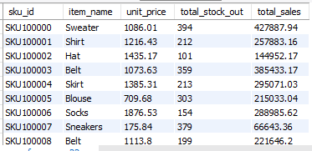

9. Discount_effect – Evaluated discount impact on stock movement per category.
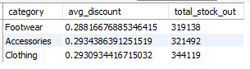

10.Warehouse_reorder_priority – Ranked warehouses by number of items needing reorder.
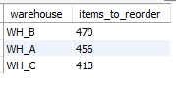

5. VISUALIZATION & INSIGHTS (POWER BI):
An interactive dashboard was built to present inventory insights:

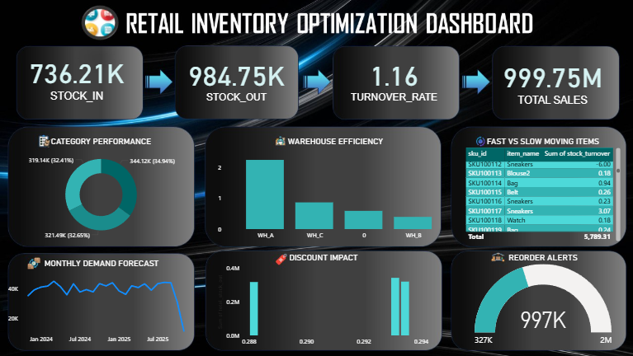

- Total Inventory Overview: KPI cards showing Total Stock In, Total Stock Out, Average Turnover Rate, Total Sales Value.

- Category Performance: Donut chart showing total stock-out per category (category_summary).

- Warehouse Efficiency: Clustered column chart comparing average turnover per warehouse (warehouse_performance).

- Fast vs Slow-Moving Items: Table listing SKU ID, Item Name, and stock turnover (inventory / slow_skus).

- Monthly Demand Forecast: Line chart showing monthly stock-out trends (monthly_sales) with forecast.

- Discount Impact: Stacked column chart showing average discount vs stock-out per category (discount_effect).

- Reorder Alerts: Pie chart highlighting SKUs needing reorder (reorder_analysis).

6. BUSINESS RECOMMENDATIONS:

- Set Reorder Points: Trigger reorders when closing_stock < reorder_level.

- Focus on Fast-Moving SKUs: Maintain sufficient stock in all warehouses.

- Manage Slow-Moving SKUs: Use promotions or bundle offers to reduce inventory.

- Warehouse Optimization: Transfer stock between warehouses based on turnover rates.

- Discount & Pricing Strategy: Adjust discounts to improve sales while protecting margins.

- Supplier Management: Collaborate with suppliers with shorter lead times for efficient stock replenishment.

